Lab report 2

85/100

Question 1

Raster graphic is collection of various colors of pixel while vector graphic is collection of straight and curved line which calculated by maths.

Raster graphic will lose quality while it is being enlarged because it is composed by pixel, it will show zigzag when enlarged.

Vector graphic will not lose quality while enlarging, because it is not make up by pixel.

Question 2

Translation:

For translation, we have a 3 X 3 matrix $\left[\begin{matrix}1 & 0 & h \\ 0 & 1 & k \\ 0 & 0 & 1\end{matrix}\right]$ where h and k are the coordinates of the original. After that we have a vector $\left(\begin{matrix}x \\ y \\ 1\end{matrix}\right)$ for the translation. Multiply the matrix and vector, we have $\left(\begin{matrix}x+h \\ y+k \\ 1\end{matrix}\right)$, which verifies that the point (x,y) is translate to (x+h,y+k).

Scaling:  
For scaling, we have a 3 X 3 matrix $\left[\begin{matrix}h & 0 & 0 \\ 0 & k & 0 \\ 0 & 0 & 1\end{matrix}\right]$ where h and k are the original coordinates. After that we have a vector $\left(\begin{matrix}x \\ y \\ 1\end{matrix}\right)$ for the scaling. Multiply the matrix and vector together, we have $\left(\begin{matrix}hx \\ ky \\ 1\end{matrix}\right)$.

Rotation:  
For rotation, we first have a matrix $Rot(a)\left[\begin{matrix}cos⁡(a) & -sin⁡(a) & 0 \\ sin⁡(a) & cos⁡(a) & 0 \\ 0 & 0 & 1\end{matrix}\right]$ which defines the angle for rotation. After that we have a vector $\left(\begin{matrix}x \\ y \\ 1\end{matrix}\right)$ for the original point. Multiply the matrix and vector together, we have $\left(\begin{matrix}x' \\ y' \\ 1\end{matrix}\right)$ which(x’, y’) is the coordinates after rotation.

Reflection: $$\left[\begin{matrix}x' \\ y' \\ 1\end{matrix}\right]=T*\left[\begin{matrix}x \\ y \\ 1\end{matrix}\right]$$

T is different when reflecting along different line. Here are 4 situation.

x-axis: $\left[\begin{matrix}1 & 0 & 0 \\ 0 & -1 & 0 \\ 0 & 0 & 1\end{matrix}\right]$ y-axis: $\left[\begin{matrix}-1 & 0 & 0 \\ 0 & 1 & 0 \\ 0 & 0 & 1\end{matrix}\right]$ Line y=x: $\left[\begin{matrix}0 & 1 & 0 \\ 1 & 0 & 0 \\ 0 & 0 & 0\end{matrix}\right]$ origin: $\left[\begin{matrix}-1 & 0 & 0 \\ 0 & -1 & 0 \\ 0 & 0 & 1\end{matrix}\right]$

Where (x,y) is the original position and (x’,y’) is the new position after reflection.

Section 2

1. Because we have to move from $\left(\begin{matrix}0 \\ 0\end{matrix}\right)$ to $\left(\begin{matrix}5 \\ 5\end{matrix}\right)$ and i will equal to 50 finally, therefore we can plus i/10(50/10 = 5).
2. Programming coding:

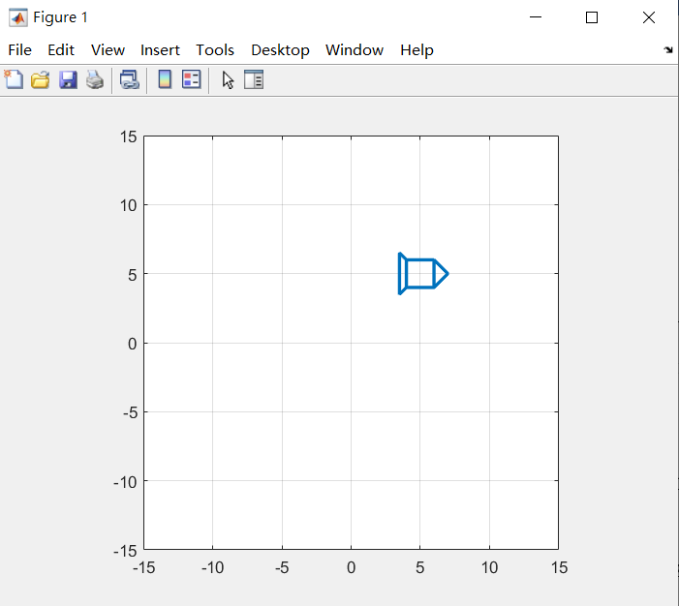x=[1 -1 -1 1 1 2 1 -1 -1.5 -1.5 -1;

1 1 -1 -1 1 0 -1 -1 -1.5 1.5 1];

for i=1:50

xx=x+i/10;

plot(xx(1,:),xx(2,:),'Linewidth',2);

axis([-15, 15, -15, 15]);

daspect([1 1 1])

grid on

drawnow

end

1. Because we want to enlarge 2.5 times, therefore we can type i/20 (50/20=2.5) and times x.

4) programming coding:

x=[1 -1 -1 1 1 2 1 -1 -1.5 -1.5 -1;

1 1 -1 -1 1 0 -1 -1 -1.5 1.5 1];

for i=1:50

xx=(i/20)\*x;

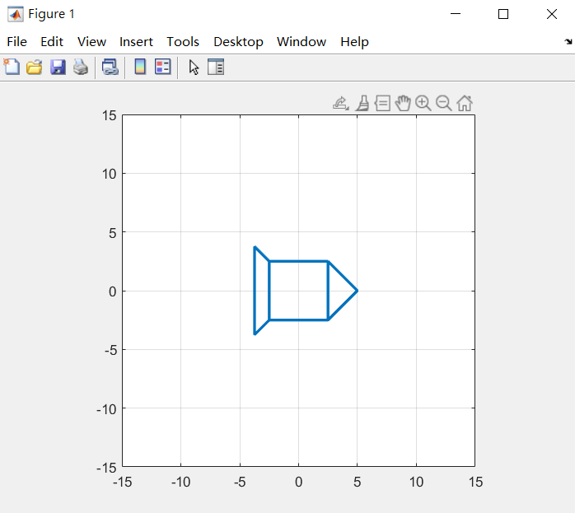 xx= (xx-xx)/x

plot(xx(1,:),xx(2,:),'Linewidth',2);

axis([-15, 15, -15, 15]);

daspect([1 1 1])

grid on

drawnow

end

1. Define a 2x2 matrix $R=\left[\begin{matrix}cos⁡(a) & -sin⁡(a) \\ sin⁡(a) & cos⁡(a)\end{matrix}\right]$, a = i\*(pi/2)\*(1/50) for positive angle, a = i\*(pi/2)\*(1/-50) for negative angle(in the a maximum is 180), then R\*x.
2. Programming coding:

x=[1 -1 -1 1 1 2 1 -1 -1.5 -1.5 -1;

1 1 -1 -1 1 0 -1 -1 -1.5 1.5 1];

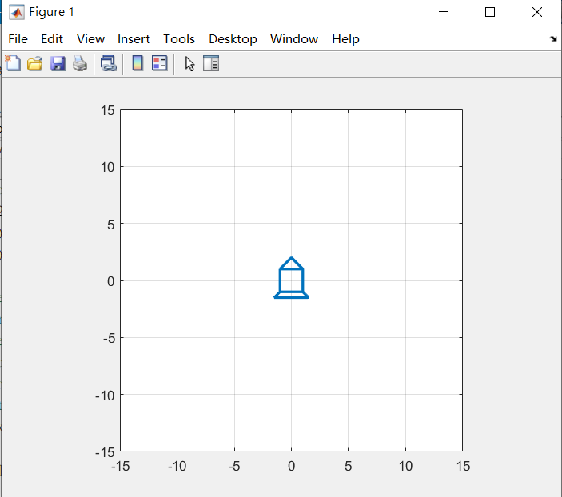for i=1:50

a = i\*(pi/2)\*(1/50)

R = [cos(a) -sin(a);

sin(a) cos(a)];

xx=R\*x

plot(xx(1,:),xx(2,:),'Linewidth',2);

axis([-15, 15, -15, 15]);

daspect([1 1 1])

grid on

drawnow

end

1. Programming coding:

x=[1 -1 -1 1 1 2 1 -1 -1.5 -1.5 -1;

1 1 -1 -1 1 0 -1 -1 -1.5 1.5 1];

x1 = 0:0.2:10;

x2 = -0.2\*(x1-5).^2+5;

for i=1:length(x1)

s=-0.4\*(x1(i)-5);

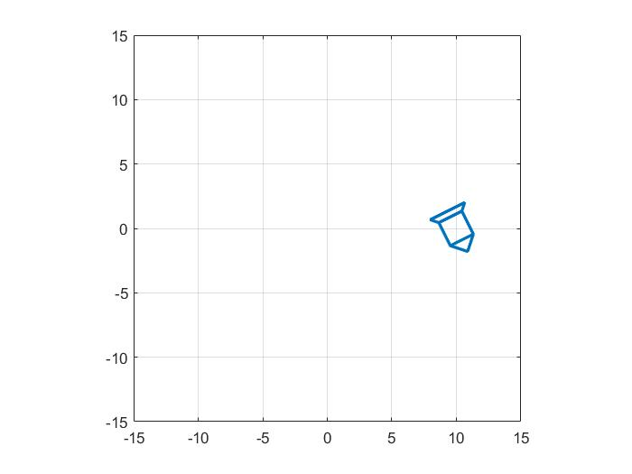a=atan(s);

R = [cos(a) -sin(a);

sin(a) cos(a)];

d = [x1(i);x2(i)];

R = R\*x

xx=R+d;

plot(xx(1,:),xx(2,:),'Linewidth',2);

axis([-15, 15, -15, 15]);

daspect([1 1 1])

grid on

drawnow

end